AI AS A MAKER OR DESTROYER OF SCIENCE? EXPLORING THE SCIENCE OF SYNTHETIC SCIENCE — TECHNICAL APPENDIX

OVERVIEW

The purpose of this technical appendix is to provide additional information on a proof of concept for the project, in which we simulate two academic communities (i.e., “worlds”). This unfolds over two phases. We would like to reiterate that this is merely a starting point, and we hope to expand on the breadth and depth of these simulated environments by an order of magnitude. We first briefly describe the two phases, offer some clarifications, and then provide more details about each phase.

Phase 1 - Generation. This phase comprises two separate parts, which we call stages. Stage 1 sets the rules of the two environments and grounds the world in the SMJ corpus. Stage 2 creates the actors, the hidden truths and the inputs they work on, including planted false findings and planted data problems. Broadly, this proof of concept is built on establishing a knowledge base (using prior SMJ articles), which helped us scope theoretical boundaries. We aim to expand on this scope for the full project. In stage 2, we provided a few parameters for the design, but during the generation phase we also let AI make decisions about how to construct the environments (which we call “worlds”). Essentially, we let AI design worlds in which other AI agents operate as scientists.

Phase 2 - Implementation. This phase also comprises two stages. Stage 3 runs language-model agents through both environments for 20 quarters (five simulated years). Stage 4 re-scores everything they produced against the hidden truth. The two environments are the “journal world” (i.e., blind peer review certifies papers) and the “repository world” (an alternative, lab-based model wherein labs share data and certify claims by independent reproduction). As an exploration, we also varied the salience of career pressures that researchers felt (in the journal world). We then ran the environments multiple times. To have comparisons across each world, we ran the journal world and repository world three times with the same parameters. We then ran the journal world two more times after inducing career pressures (via adding clear tenure pressures in the researcher profiles that were part of the AI agents’ configurations).

Additional Clarifying Information

First, the entire engine was developed using Claude AI agents, which kept documentation of the progress. In Tables A1 and A2 below, we provide descriptions of the additional materials for review as well as where to find them. To maintain anonymity, we do not link the GitHub URL directly and instead have provided it to the editors. A link to the files on Zenodo can be found here.

Second, as a caveat everything reported here is a proof of concept, relying on one input journal (SMJ), one population size (150 scientists per run) and eight runs. The full study will scale to inputs that incorporate all top-tier management journals and about 100 synthetic environments (see “from pilot to full study” section below).

Since we relied on Claude to construct and implement the worlds, some of the vocabulary may not be straightforward. The following is a glossary of key terms:
- Seed: one simulation run of an academic community; seeds vary in their configurations (i.e., research questions; ground truths; scientist profiles). Can be thought of synonymously with “run.”
- Environment: referring to either the journal or the repository systems (also referred to as the “world[s]”).
- Certified unit: what an environment certifies as knowledge, either the focal finding of a published paper or an endorsed focal claim.
- Grounded / declared: a setting read from the SMJ corpus, or one set by the designers with no corpus source.
- Fringe questions: invented research questions that imitate the field’s habit of coining constructs.
- Rule agents: scripted agents with no model calls, used for the journal’s warm start, tests and fast mode.
- Warm start: 16 quarters played by rule agents before quarter 1, so the journal’s review pipeline is full when live agents begin. This process only exists to create a “pre” period for scientists operating in the journal review system, so that they have journal articles to review/edit/publish from the first quarter.
- Compute: budgeted tokens, the planned cost per call used for resource allotments (not tokens actually used).

Table A1. Additional Materials.
Where | Item | Contents
GitHub | synthsci/ | The simulation engine: world and dataset generation, the journal and repository environments, every agent prompt and output schema, orchestration, budgets, scoring and the knowledge audit
GitHub | configs/ | Every setting: base settings, one file per world, the seeding manifest (which SMJ-derived tables seed the worlds), and fast-mode, tariff and leak-scan settings
GitHub | grounding/ | The aggregate SMJ and four-journal tables that seed the worlds, the scripts that built them, and a description of each table
GitHub | analysis/ | Result scripts and outputs: the 20-quarter results, knowledge lineage (citations and evidence chains), and a catalogue of every agent instruction with worked examples
GitHub | tools/, tests/ | Utility scripts (figures, fast-mode calibration, run manifests, checks) and the automated test suite
GitHub | docs/ | This appendix, the proposal, the supplement on building the SMJ corpus (Stage 0), and figures
GitHub | README.md, DATA.md | How to install, run and reproduce the results; what data are shared and why
Zenodo | S0-150, S0P-150, R-b-150 (one zip each) | Complete run folders for the journal, journal-with-career-pressure and repository worlds, 8 quarters (3, 2 and 3 seeds)
Zenodo | the same names with -x20 | The same eight runs extended to 20 quarters
Zenodo | _warmstart-datasets | Datasets analysed in the rule-agent warm start (quarters −15 to 0) of the journal worlds
Zenodo | MANIFEST.csv, SHA256SUMS.txt, README.md | A hash for every file before and after local paths were replaced, checksums of the zips, and a guide to the deposit

Table A2. Contents of Each Run Folder (<world>/<seed>/llm/)
Item | Contents
run.json, config.resolved.yaml | Run identity, the full configuration and the hashes of its inputs
tasks/<task id>/ | One folder per agent task: the exact instruction (prompt.md), the materials given, the agent’s output/, token use (usage.json) and the engine’s check of the output (validation.json)
ledger/, state/, population/, handbook/, legacy/, budget/, dispatch/, log/ | The engine’s quarter-by-quarter record of papers, reviews, decisions, datasets, scientists, the inherited literature and the handbook
landscape/ | The true answers, which no agent saw
audit/ | The knowledge audit, which scores what the field published or certified against the truth
agent_report.md | Agent calls, tokens and models by role
_void/ (some runs) | Attempts stopped before completion and leak-scan false positives, each with a note giving the reason; none is used in any reported result
REUSED.md (some runs) | Quarter-0 handbook outputs reused unchanged where their instructions and inputs were identical, with each file’s hash

A visualization of the process can be found in Figure A1. As a final clarification, “Stage 0” is in reference to the preparatory work we did to use SMJ data as input. Details on that can be found in the /docs folder referenced above.

Figure A1. Visualization of Pipeline.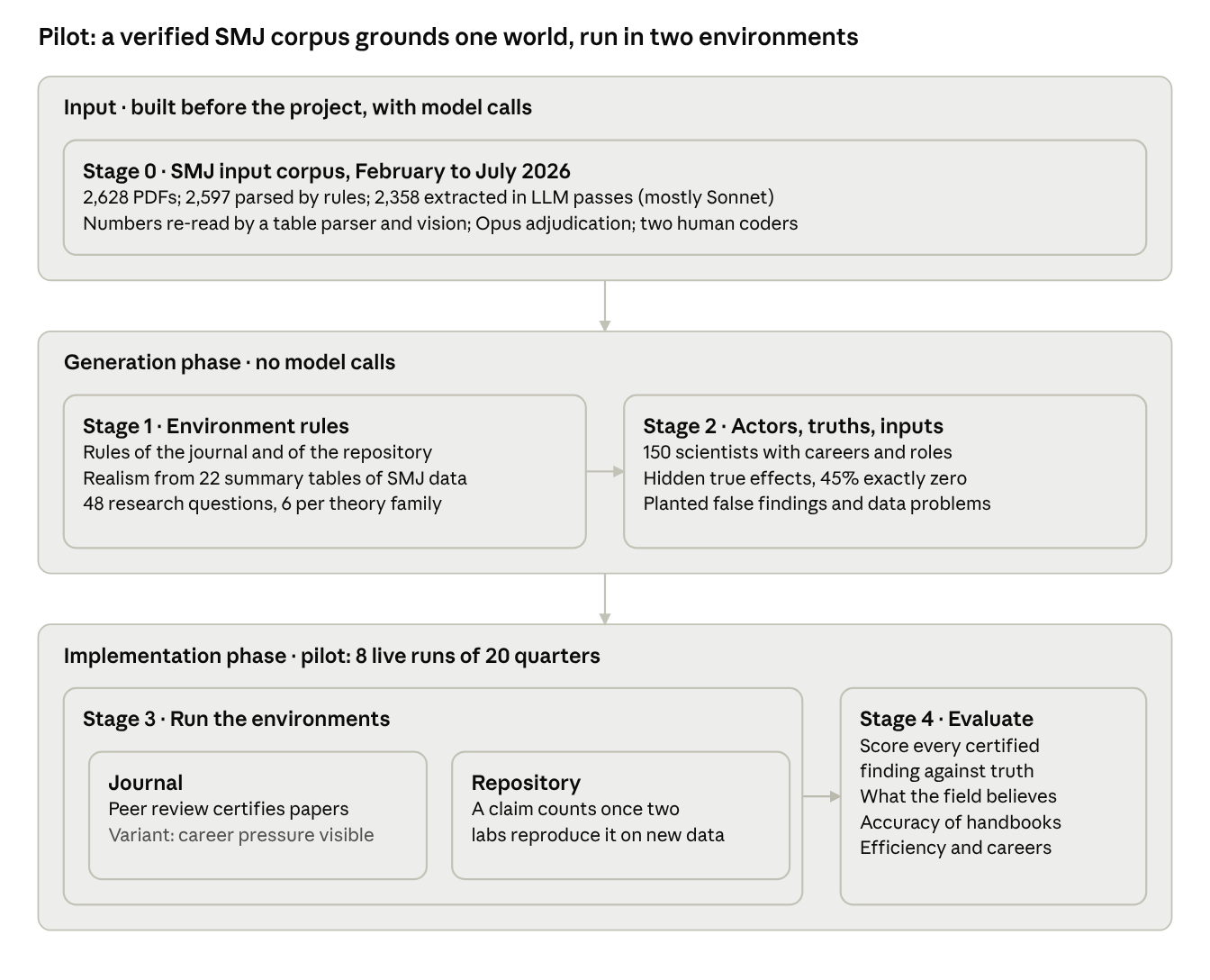

Generation, stage 1: environment rules and grounding
Both environments share one world and differ only in how knowledge is certified. Every institutional rule is a configuration key, so an environment is a file (configs/scenarios/), not separate code.

Table A3. Environment Comparison.
 | Journal (paper world, S0-150) | Repository (R-b-150)
Who does research | 150 scientists; each leads one study at a time with 0 to 3 coauthors. Authors run their own analyses. | The same 150 scientists, grouped into 15 labs; a lab head commissions analyses.
Data | One fresh dataset per study | Shared deposits per question; fresh, reused or pooled
Unit of knowledge | A published paper; its focal hypothesis is the certified unit | A claim (one relation); an endorsed focal claim is the certified unit
Certification rule | Desk screen, three blind referees, editor decision, one revision round | Two independent labs reproduce the claim on fresh data; the engine judges reproduction
Career credit | Publications | Endorsed claims plus half credit per verification
Resources | Its realized spend becomes the repository’s budget | Compute matched to the paired journal run each quarter

The career-pressure variant (S0P-150) is the journal with three extra lines on each author’s record card: the tenure clock, colleagues’ promotion outcomes and the journal’s acceptance statistics. It shares every random draw with its journal twin, so the two can differ only through what agents see.

Grounding. The world is seeded from a verified extraction of 2,358 Strategic Management Journal articles (1,709 quantitative and 154 mixed-method, published 1997–2025). We used this as input and derived 22 seeding tables, which have myriad variables from those papers pertaining to the correlations, results, hypotheses, and more. For each run, these tables are used to arrive at:
- the 48 core research questions: the most-studied construct pairs in SMJ, six in each of eight theory families, with the direction most papers predicted;
- study designs, units of analysis and sample sizes;
- correlation structures, raw scales and measurement reliability for generated data;
- review latency (SMJ received-to-accepted times) and productivity (0.25 papers per author-year, from four-journal author profiles).

Some additional parameters were set from information beyond the SMJ input. These settings are labelled declared (for example the tenure clock, referee numbers and the density of planted data problems). The share of true nulls and the effect scale are anchored on SMJ but not yet fitted.

More information about the seeding tables follows.

From the corpus to the seeding tables
Seeding tables. grounding/build_grounding_inventory.py maps variable names to constructs, by an exact alias in the construct dictionary first and then a curated family pattern. It writes 56 SMJ tables to grounding/tables/.

The engine reads 22 of these tables through the manifest configs/seeding/smj.yaml (20 derived, 2 declared) and writes each one’s SHA-256 hash into every run. Twelve feed the generator; the other ten are recorded but unused, or serve only as anchor checks.

Table A4. Seeding Tables.
Seeding table | Gives the world | Used
02b top-50 and all construct pairs | The 48 core questions and their predicted signs | yes
02a theory families | Scientists’ home theories (for example .295 resource-based view) | yes
pair_theory.csv | Theory family of each pair (62 rows, declared) | yes
02e predicted direction | Predicted signs for fringe questions (+ .599, − .310) | yes
04a, 04b design and unit shares | Study designs and units of analysis | yes
04c sample-size quantiles | N per dataset (floor 60 declared; cap 45,841, the SMJ p90) | yes
06c pooled 25 × 25 correlation matrix | Correlation structure of every dataset, perturbed with SD .18 (Fisher z) | yes
03e measurement quality | Scale reliability (median alpha .81, p10 .70) | yes
03g descriptives by family | Raw means and SDs of variables | yes
construct_measures.yaml | Variable names and definitions (declared) | yes
05a, 05c partial-r distributions | Anchor checks for the true effects | anchor only
03a, 04b panels, 04d, 04f (2), 04h, 06b, 07a | Construct roles, panels, estimators, controls, causal strategies, between-paper SD, hypotheses per paper | no
Review latency (SMJ dates only; SMJ received-to-accepted median 22.1 months, p90 43.5; n = 773) and productivity (0.25 papers per scientist-year) were also included to represent general timeframes of the publication process and expectations of publishing.

Generation, stage 2: actors, truths and inputs
A run’s seed fixes three layers: the world (questions, truths, inherited literature), the population (scientists) and the run (every dataset and random tie-break). The same seed in two environments gives the same truths and scientists across each world, which is how runs are paired.

Each question has a true effect θ that no agent ever sees.

How the true effects are drawn
Every question’s true effect θ is drawn once per seed, before any agent acts, by _draw_truth in synthsci/landscape.py with settings from configs/base.yaml. θ is the partial correlation between error-free X and Y, holding the standard controls and one hidden confounder U constant.
- With probability π₀ = .45, θ = 0 (a true null).
- Otherwise |θ| is half-normal with scale .05.
- The sign matches the theory’s predicted sign with probability q_T, drawn once per theory family per seed from Uniform(.55, .95). Fringe questions use the mean q_T across families instead.

The scorer then classes each θ as null (0), negligible (0 < |θ| < .02), positive (≥ .02) or negative (≤ −.02).
Anchored, not fitted. The three settings follow the grounding inventory’s provisional defaults (π₀ about .4–.5, scale about .05, q about .8; the config’s q_T averages .75). Three corpus figures anchor them:
- the median |partial r| in very large samples (N ≥ 5,000) is .022 (n = 784), a ceiling for typical true effects;
- the median r of “not supported” verdicts is .001, a lower bound on π₀;
- the median published |partial r| of direct effects is .084 (n = 3,086), larger because of selection.
The planned fit, a selection model on the verified t-statistics followed by simulation-based calibration, has not been run for this pilot.

Other hidden quantities, all declared. Each question also has:
- two moderators, each zero with probability .6, otherwise half-normal with scale .03;
- a subsample offset with SD .02;
- a secondary outcome whose truth is θ plus noise with SD .01 (when θ = 0 it stays exactly 0 with probability .7);
- a confounder U with r(U,X) and r(U,Y) from Uniform(.05, .20), and a 40–80% share of U that is constant within a firm;
- for core questions only, an instrument offered with probability .25 (first-stage F 8–40, exclusion violation .03).

Table A5. True Effects Regarding Core and Fringe Questions.
Seed | Questions | Null | Negligible | Positive | Negative | Median non-null |θ| | Max |θ|
1 | 48 core | 22 | 7 | 11 | 8 | .038 | .109
1 | 150 fringe | 58 | 23 | 33 | 36 | .035 | .127
2 | 48 core | 21 | 12 | 11 | 4 | .024 | .114
2 | 150 fringe | 67 | 22 | 32 | 29 | .037 | .143
3 | 48 core | 23 | 11 | 8 | 6 | .030 | .130
3 | 150 fringe | 57 | 34 | 28 | 31 | .030 | .145

Drawn q_T ranges from .55 to .95 across families and seeds. For example, the resource-based view’s q_T is .65, .58 and .94 in seeds 1–3, while transaction cost economics stays near .79 in all three.

Fringe questions. Each seed coins 150 questions by pairing an invented construct with a standard outcome. Each gets a family from SMJ family shares, a predicted sign from SMJ predicted-sign shares, and a truth drawn by the same rule, except that its sign uses the mean q_T across families and it never gets an instrument. A fringe question with three certified findings joins the core. Pool size, word lists and threshold are declared.

From θ to a dataset. synthsci/datasets.py builds each study’s data in seven steps:
- Draw N from the SMJ quantiles.
- Perturb the pooled correlation matrix.
- Simulate latent X and Y so that their partial correlation equals θ, with controls, U, and firm and year shocks.
- Add measurement error to X and Y at the drawn reliability.
- Convert to SMJ raw scales.
- Make about 10% of two controls missing.
- Plant up to two data problems.

The ledger stores the estimate a correct analysis should recover, along with oracle fits with each problem handled and left in. A dataset is admitted only if the correct analysis recovers its target within 1.96 SE and each problem moves a naive estimate. After seven failed draws the generator drops one problem, after nine another, and after eleven it keeps the last draw, flagged as inadmissible.

The inherited literature. synthsci/legacy.py writes 100 legacy papers: 70 on core questions and 30 on fringe questions, each an analytic draw from its question’s truth. The scripted author handles each planted problem with probability .8 (declared). A paper is “published” only if its focal |t| > 1.96, so the false share of the starting literature is an outcome, not a set value. In the journal worlds the inherited units are the 100 legacy papers plus the warm-start papers: 30 of 120 units (.25), 48 of 118 (.41) and 35 of 113 (.31) in seeds 1–3. The repository inherits only the 100 legacy studies. The career-pressure seeds 1 and 2 inherit the same literature as the journal seeds 1 and 2. This was a decision to help bound the scope of these pilot runs; subsequent runs will target a larger scale and scope.

Seed layers. synthsci/config.py derives three layer seeds from the master seed (SHA-256), and every random stream is seeded from its layer and tags, so streams do not depend on draw order.
- World layer: q_T, designs, truths, fringe questions and legacy papers.
- Population layer: scientist profiles, labs and career steps.
- Run layer: availability, teams, dataset seeds and the de-identification permutation.

Keeping it hidden. landscape/truth.json stays in the run folder and never enters a task folder. Every text an agent receives is scanned against configs/leakscan.yaml (design terms such as theta, planted, oracle, q_T, truth.json; strict phrases such as “ground truth”), and a hit stops the task.
Sources: synthsci/landscape.py, datasets.py, legacy.py, config.py; configs/base.yaml; grounding/GROUNDING-INVENTORY.md §2(d), §6.2.

Actors. Every role is played by a Claude agent (Sonnet, except one Opus handbook writer). Table A6 below summarizes these roles.

Table A6. Actor Roles.
Role | Environment | What it does
Author | Journal | Picks one of six questions, opens real data, writes and runs Python, writes the paper and a structured claims file
Referee | Journal | Reads the paper, table, code, codebook and abstracts of earlier papers on the question (no data); recommends, flags flaws, states a probability the finding holds
Editor | Journal | Desk screens and decides accept, revise or reject
Lab head | Repository | Chooses analyses and data, files claims, votes, assigns verifications, answers challenges
AI analyst | Repository | Runs an analysis on real data for a lab member
Verifier | Repository | An analyst from another lab who re-runs a claim’s code and its own analysis on fresh data
Handbook writer | Both | Three writers state what the field knows about each question at fixed quarters
The 150 scientists carry seeded career stages, home theories (drawn from SMJ theory shares), methods and productivity. Careers move every four quarters: tenure at year six against a bar of two publications, promotion, exit and replacement entrants. Agents are never told they are in a study or that they are models.

Planted inputs.
- False literature. The 100 legacy studies are simulated from the true effects and published only if significant (|t| > 1.96). Some inherited findings are therefore false by construction: 25% to 41% of inherited units per seed.
- Data problems. Every dataset is generated on demand from the question’s truth, with a hidden confounder and measurement error. About 60% carry one planted problem and 10% two: duplicated rows, a vendor recording a variable in percent instead of fractions, mis-coded values, a one-year unit mismatch, a mediator offered as a control, or an omitted size control. Problems are visible only in the data, never in the codebook. The registry has eight types, including reverse-coded items and selection on the outcome; the admissibility check removed every selection-on-outcome problem drawn and about half of the bad controls, so the realized mix differs from the declared one. A dataset is kept only if a correct analysis recovers the target and each problem, left in, moves the estimate.
- Fringe questions. 150 coined questions per seed imitate the field’s habit of inventing constructs; each has its own hidden truth.

Figure A2. Sample Focal Research Questions with True Effects.
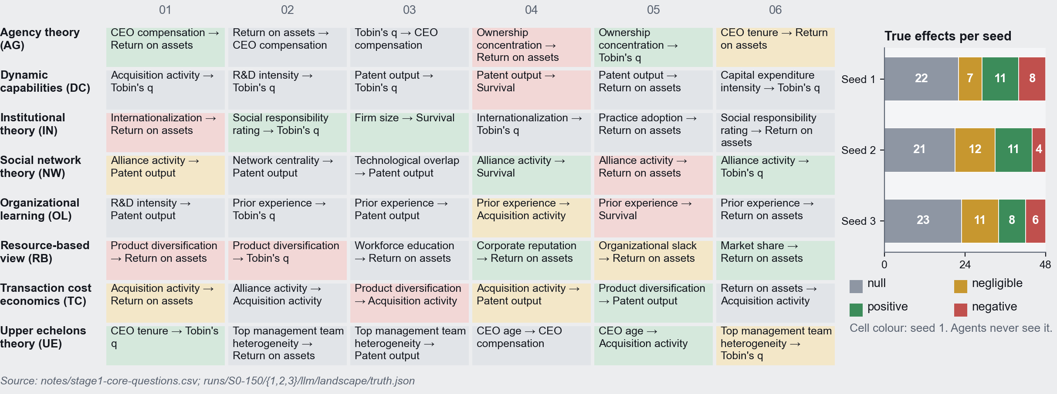

Implementation, stage 3: running the environments
The pilot completed eight live runs of 20 quarters each: the journal at seeds 1 to 3, the career-pressure journal at seeds 1 and 2, and the repository at seeds 1 to 3. Each ran first to 8 quarters and was then extended to 20 on a copy; the 8-quarter originals were verified byte-identical afterwards.

How a quarter runs. The engine decides who acts, builds each agent’s task folder (instructions, record card, menu, data files) and stops. A driver dispatches one agent per task; the agent works only inside its folder and writes structured outputs. The engine then validates every output, re-runs each author’s analysis.py to confirm it reproduces the reported table, applies the environment’s rules and moves to the next quarter. Across the runs this produced 4,509 live agent prompts (completed tasks; repeated and voided attempts excluded) from 11 role templates, unchanged from quarter 1 to 20.

Resource parity. Each repository run receives, quarter by quarter, the compute its paired journal run actually used; data may float up to four times the journal’s use. Every request deferred for lack of budget names the resource that blocked it. In the 20-quarter runs the repository used 0.79 to 0.99 of its pair’s compute and about four times its data. The ceiling applies to each quarter’s admissions, so the cumulative ratio can drift above it: one seed reached 4.09 times by quarter 20.

Tokens and cost. The pilot’s simulations processed about 4.8 billion tokens, about $1,173 API-equivalent.

Implementation, stage 4: evaluating performance
Because of how the data are stored, scoring is deterministic and makes no model calls; synthsci audit re-runs it from the ledger at any time. Some characteristics of performance that are worth explicating:
- Certified units. One definition in both environments: the focal estimate of a published paper, or an endorsed focal claim. A unit states the direction of a significant estimate, or “no effect”. Inherited units are reported apart from what a run adds.
- Truth check. Each unit is a true discovery, false discovery, missed effect or correct null against θ.
- What the field believes. Five rules turn units into one belief per question: vote count, pooled meta-analytic estimate, most-attended unit, the handbook panel, and an attention-weighted vote. Beliefs are scored for accuracy, calibration and net knowledge (correct minus wrong beliefs held with confidence).
- Handbooks. At fixed quarters three writers state the field’s knowledge from the published papers (journal) or from the claim registry with each claim’s status (repository), never from the data or the truth, with constructs and theories coded so the model’s own background knowledge cannot fill gaps. Their answers are scored like any belief.
- Process and efficiency. Coverage, self-correction of false inherited findings, certification speed, referee and verifier accuracy, compute and data per correct answer, and career outcomes.

What we track
Because every finding has a known truth, each record below can be joined to whether the finding was right.

Table A7. Summary of Data and Variables Stored.
Record | What it holds | Environment | Where
Hidden world | Questions, true effects, confounders, theory reliability, inherited literature | Both | landscape/, legacy/
Population and careers | Each scientist’s stage, theories, methods, record; promotions, tenure exits, entrants | Both | population/, ledger/events.jsonl
Hypotheses | Every stated hypothesis with estimate, SE, N, verdict and truth class | Both | ledger/hypotheses.jsonl
Datasets | Every dataset drawn: size, seed, hash, planted problems, oracle fits with and without each problem | Both | ledger/datasets.jsonl
Agent work | Each agent’s full instructions, inputs, code, outputs and token use | Both | tasks/<task id>/
Peer review | Reviews, recommendations, stated validity probabilities, editor decisions | Journal | ledger/reviews.jsonl, ledger/decisions.jsonl
Citations | Which papers each study builds on; realized citations at publication | Journal | ledger/citations.json
Claims and certification | Claims, deposits used, verifications and their verdicts, endorse or challenge votes, status changes | Repository | ledger/claims.jsonl, verifications.jsonl, votes.jsonl
Budget | Compute and data debited per call and dataset; every deferral and the resource that bound it | Both | ledger/budget.jsonl
Field knowledge | Handbooks at fixed quarters and their scores; the end-of-run audit | Both | handbook/, audit/

Built on top of these records. The knowledge-lineage datasets trace how findings travel: citation networks in the journal, data and verification chains in the repository, and whether false findings are built on as often as true ones (analysis/lineage/). The instruction catalogue indexes every live prompt with its template and hash (analysis/instructions/).

Figure A3. Sample Outcomes Across Worlds.
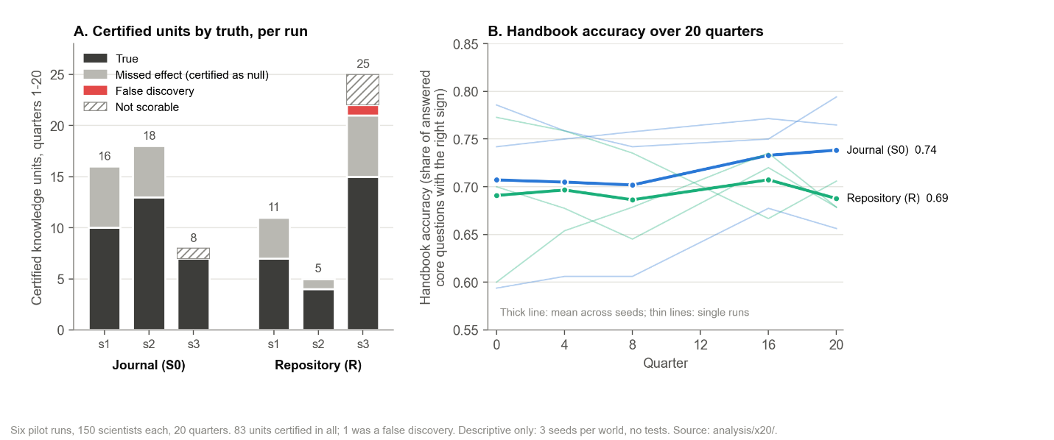

Figure A4. Sample Outcomes Across Worlds.
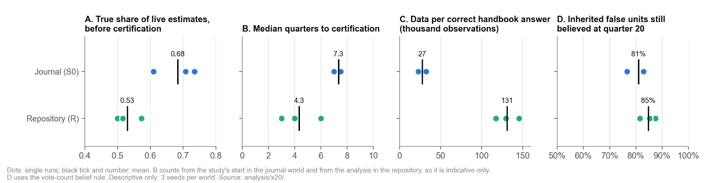

From pilot to full study
The pilot shows that the instrument works end to end. The full study will run the same engine at a scale that supports inference. It will widen the input beyond SMJ, and create about 100 synthetic environments, across which we will vary possible interventions that can be implemented in the real world.

What the pilot established.
- Live agents can carry both worlds through 20 quarters under one fixed rulebook, with every output validated and every author’s code re-run. It appears we can replicate this for longer time horizons.
- Every certified finding can be scored against a known truth, and paired runs share every random draw, so world differences are not draw differences.

Design of the full study.

Table A8. Comparing the Pilot and the Intended Full Study.
 | Pilot (done) | Full study (planned)
Input corpus | SMJ only: 2,358 articles, verified in Stage 0 | SMJ plus further management journals, each processed as in Stage 0
Synthetic environments | 3 seeded worlds | About 100
Worlds compared | Journal (3 seeds, plus 2 seeds of its career-pressure variant) and repository (3 seeds) | Two: journal and repository; career pressure is one variant of the journal
Runs per world | 3 journal, 2 career-pressure, 3 repository | A configuration value (seeds per world), set when the ~100 environments are allocated; running each environment in both worlds gives matched pairs
Horizon | 5 years | 30 years
Analysis | Descriptive, with two or three seeds per world | Paired comparisons with uncertainty across environments

Inputs beyond SMJ. The keyword pipeline of Stage 0 already parsed four journals, including AMJ, OS and ASQ, but only SMJ went through the verified multi-pass extraction. This was due to the practical constraint of needing to scope the pilot around a theoretical domain that was fairly easily discernible (i.e., “strategy research”).

This appendix was generated by Claude and was edited by the authors.

